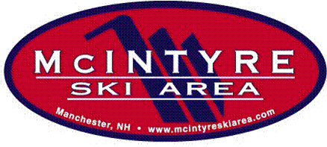

McIntyre Ski Team Application

2021/2022

Return your application and check before December 18, 2021. Applications are accepted on a first come-first served basis. All fees must be paid in advance. No refunds after December 30, 2021.

Racer’s Name:_______________________________________________________ [ ] Male [ ] Female

Address: _____________________________________________________________________

Date of Birth: _______________________ Age as of December 31, 2021: _______________

Parent #1: _____________________________ Parent #2: __________________________
Home Phone: __________________________ Home Phone: ________________________
Cell Phone: ___________________________ Cell Phone: _________________________
Email: ________________________________ E-mail: _____________________________

Emergency Contact (if parents cannot be reached): __________________ Phone: _________________

Are there any allergies, medications, or medical conditions we should be aware of? [ ] Yes [ ] No
If Yes, please explain: ________________________________________________________________

Check your child’s appropriate age group as of December 31, 2021:
[ ] Development Team (ages 6 - 9) born 2012-2015 Cost: $415
[ ] U8 (ages 6 & 7) Born 2015 & 2014 Cost: $440 (Team)
[ ] U10 (ages 8 & 9) Born 2013 & 2012 Cost: $440 (Team)
[ ] U12 (ages 10 & 11) Born 2011 & 2010 Cost: $490 (Team)
[ ] U14 (ages 12 & 13) Born 2009 & 2008 Cost: $490 (Team)

Mail form & check to:
McIntyre Ski Team
50 Chalet Court
Manchester, NH 03104

Parent’s Signature: _________________________________Date: _____________________

Notes: Please complete one form per child.
All Race Team Members U8-U14 must have a 2021/22 McIntyre Seasons Pass. Team members will receive the early season discount of $309.00 must be purchased by 12/1/21. After 12/1/21 the season pass price will be $349.00 includes the freedom pass of participating areas.
Intro to Race Program the lift pass is included for practice nights only.
For families registering 3 children in program, please apply a 10% discount.
------------------------------------------------------------------------------------------------------------------------------
DO NOT WRITE BELOW THIS LINE
For Office Use Only:

Amount Paid: __________________ Date Paid: ___________________ Check #: ________________

