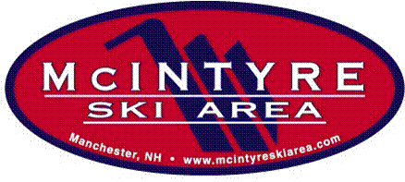

McIntyre Ski Team Forms Checklist
2021/22

- McIntyre Ski Team Application
Complete this application as soon as possible to guarantee a place on the team; all team fees should be paid by December 15, 2021. Send form and payment to:
McIntyre Ski Area/Ski Team
50 Chalet Court
Manchester, NH 03104

- McIntyre Waiver
Read and sign waiver. Return with application to McIntyre.

- McIntyre Ski Area Season Pass Application
The form is located on the McIntyre website: https://www.mcintyreskiarea.com/tickets-passes/seasonal-passes/

- USSA Membership Application
This application should be sent in as soon as possible. This membership is required for all U10, U12, and U14 skiers that will be participating in races. The membership card must be presented on each race day. The form is located on the USSA website: www.ussa.org
- Select the “Membership Tools” tab
- Select “Online Registration” or “Become a Member”
- Follow instructions (select “Alpine, USSA …”; “Youth Competitor”)

- NHARA Membership Application

This application should be sent in as soon as you receive the USSA membership notification. This membership is required for all U10, U12, and U14 skiers that will be participating in races and skills events. The form is located on the NHARA website: www.nhara.org
- Select “Online Registration - “New members” or “Renewing members”
- Follow instructions

- Reporting USSA & NHARA Numbers to the Ski Team Secretary
As soon as you receive the USSA & NHARA cards, check them to ensure the information is correct (name & class). Email the membership #’s to skiteam@mcintyreskiarea.com as soon as possible.

